Registrations & Receipts

Instructions to access and manage your registrations and receipts.

Via computer
Step 1: Go to: https://jefferson-lehigh.cloud-cme.com

Step 2: Click "Sign In" on the top left, and sign in using your email address and password.
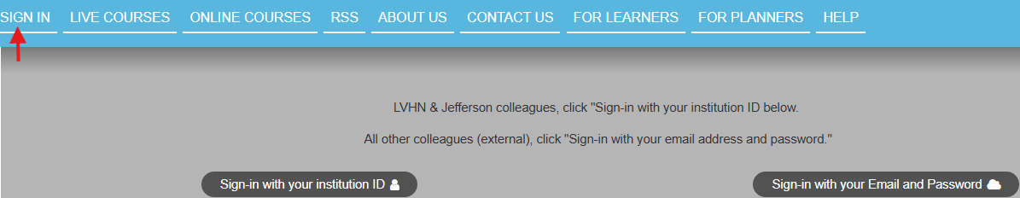

Step 3: Click the "My CME" or "My CE" button on the top right-hand side of the screen.

Step 4: Click "Registrations & Receipts."

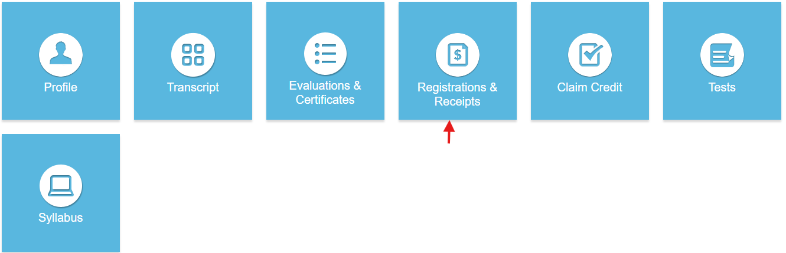

Step 5: You can view all the activities you have registered for and, if an activity has a fee, you can view your receipt. To view the receipt, click the “Receipt” button.

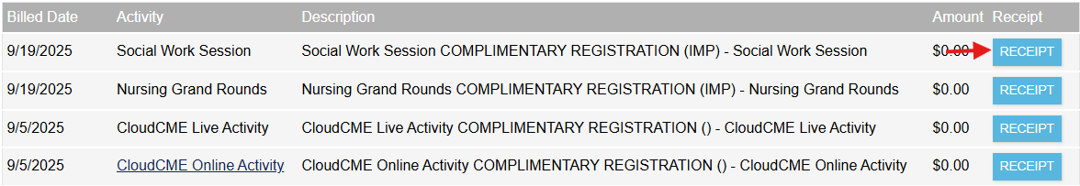

Step 6: You will see the receipt details for the activity including payment information.

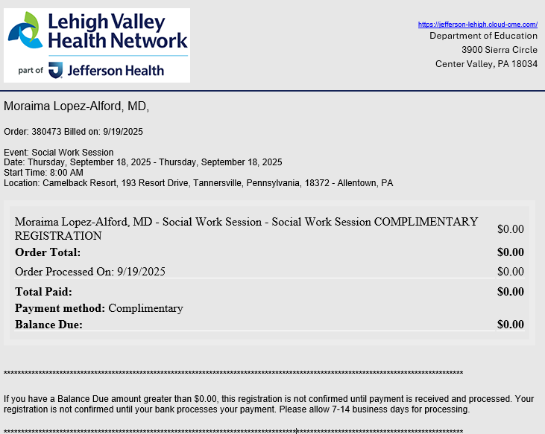
Step 7: Receipts may be emailed. Enter the email address where you wish to email your receipt and click the “Send” button.

